Exemplar: Rev. Margaret Yackel-Juleen
mryj2232@gmail.com
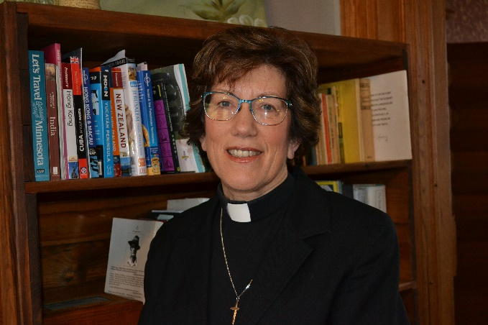
Margaret Yackel-Juleen lives with her husband Mark in an old Victorian Bed and Breakfast in Elkader, IA. She began her current call to One in Faith, a four-point parish in the rural Northeastern part of the state in the summer of 2015 after serving a rural 6-point parish in Southwestern Minnesota for 10 years as part of a team. Along with her husband of almost 40 years, she is co-founder of Shalom Hill Farm, a rural education and retreat center located on a lovely farm north of Windom, MN.

After graduation from Augustana University in Sioux Falls, SD in 1981 with a BA in English/Speech and Theatre Arts Education, Margaret and Mark were married and left for a 3-year mission teaching stint in Hong Kong. Those three years were the foundation of what has become a life of formal call to ministry for the couple. After raising 3 wonderful children, Andrew, Elizabeth and Eli, Margaret attended Luther Seminary, graduating in 2009. She also completed a two-year course in Spiritual Direction through Christos Center for Spiritual Formation in Lino Lakes, MN.
Margaret enjoys her two adorable grandchildren, getting involved in community theatre and musical opportunities, knitting and crocheting. She enjoys travel, cooking and providing hospitality to groups and individuals and sometimes finds time to read!

